append() method is a overloaded method , method name is same arguments are different

public StringBuffer append(int i)

public StringBuffer append(long l)

public StringBuffer append(boolean b)

public StringBuffer append(double d)

public StringBuffer append(folat f)

Eg: StringBuffer_Append

public StringBuffer insert(int index , int i );

public StringBuffer insert(int index , float f );

public StringBuffer insert(int index , long l );

public StringBuffer insert(int index , double );

public StringBuffer insert(int index , boolean b );

public StringBuffer insert(int index , Object o )

Eg: StringBuffer_Insert_Method

public StringBuffer delete( int begin , int end ) // deletes data from specified index to end-1

public StringBuffer deleteCharAt(int index) // deletes character at specified index

Eg: StringBuffer_Delete_Eg37

public StringBuffer reverse()

Eg:StringBuffer_Reverse_Eg38

// go through the code

public StringBuffer setLength()

// used to set only specified no of characters and remove all remaining characters

Eg: StringBuffer_Set_Length_Eg39

public void trimToSize()

This is method is used to deallocate the extra allocated free memory such that capacity and size are equal.

Eg: StringBuffer_trimToSize()_Eg40

public void ensureCapacity(int capacity)

It is used to increase the capacity dynamically based on our requirement. because normal StringBuffer and every time jvm reaches the maximum capacity for object and after that increasing its size is a costly operation. so to avoid that ensureCapacity() method is used .

Eg: StringBuffer_ensureCapacity_Eg41

StringBuffer

Every method present in StringBuffer is synchronized, so that only one thread is allowed to use the object at a time, it would create performance problems, so to overcome this we use StringBuilder

StringBuilder

It is introduced in the jdk 1.5 version

At a time more than one thread can used the object so it is not thread safe.

Threads are not required to wait, so the performance is high.

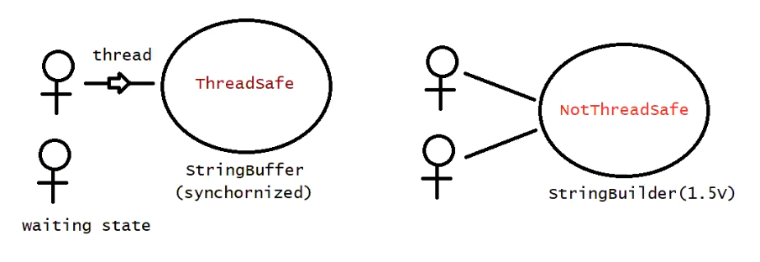

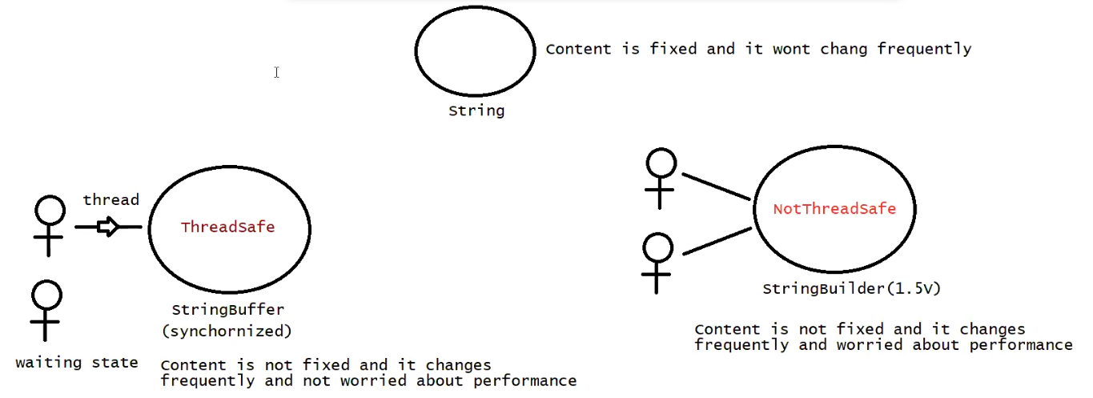

String vs StringBuffer vs StringBuilder

String -> we can choose if the content is fixed and not changed frequently

StringBuffer -> we can choose if the content is not fixed and changes frequently and it should thread safe (commonly used in banking applications )

StringBulilder -> we can choose if the content is not fixed and changes frequently and it is not thread safe

Method Chaining

Most of the methods in the String, StringBuffer, StringBuilder the return type is same. hence after applying method on result we can call another method which forms method chaining.

Note: here the after method works based on the return type of the before method, and all of them works on the same object

Eg: Method_Chaning_Eg42

Eg: Copy_Of_String_Eg43

// length property is for array and length() is of String type

Eg: Capital_String_Eg44

// go through the program.

Eg: SmallerCase_String_Eg45

// go through the program

Eg: Opposite_Case_Converting_Eg46

// go through the program

Eg: Reverse_The_String_Eg47

// go through the program

Eg: Reverse_The_String_2_Eg48

// go through the program

String_object . split(“ “)

Splits this string around the matches of the given regular expression( should be given in bracket)

Eg: String_Eg49

// go through the program

Eg: String_Eg50

// go through the program

Eg: String_Eg51

// go through the program

Eg: String_Eg52

Since assigning s2 to s1 is a runtime operation memory is allocated in the heap.

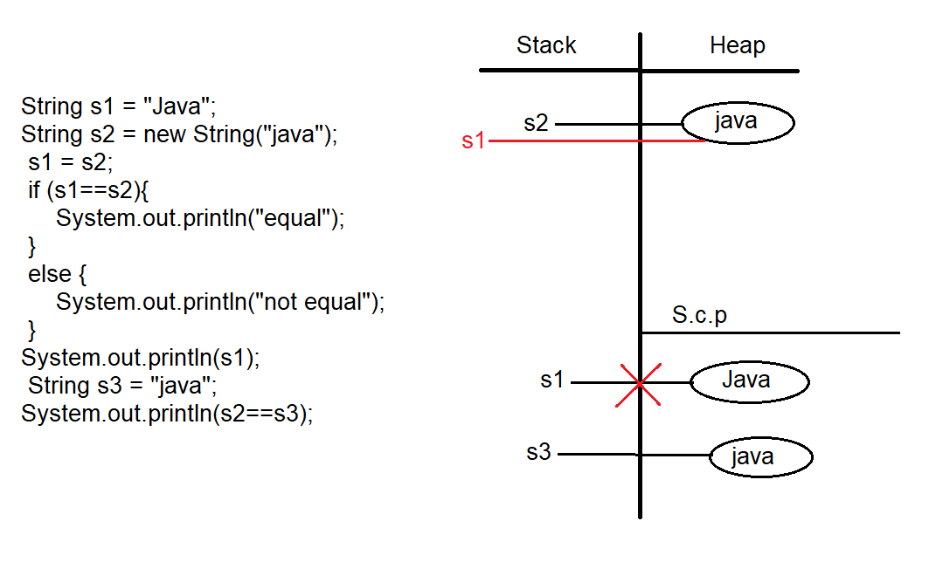

Eg: String_Eg53

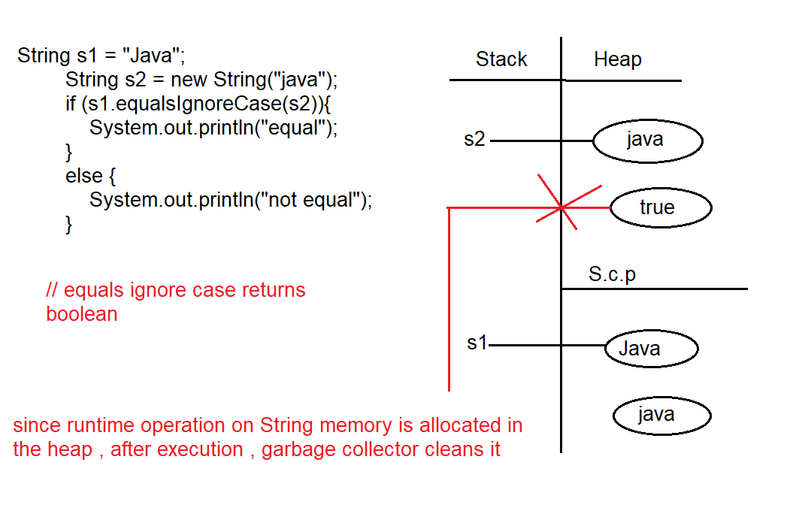

Eg: String_Eg54

// go through the code

Eg: String_Eg55

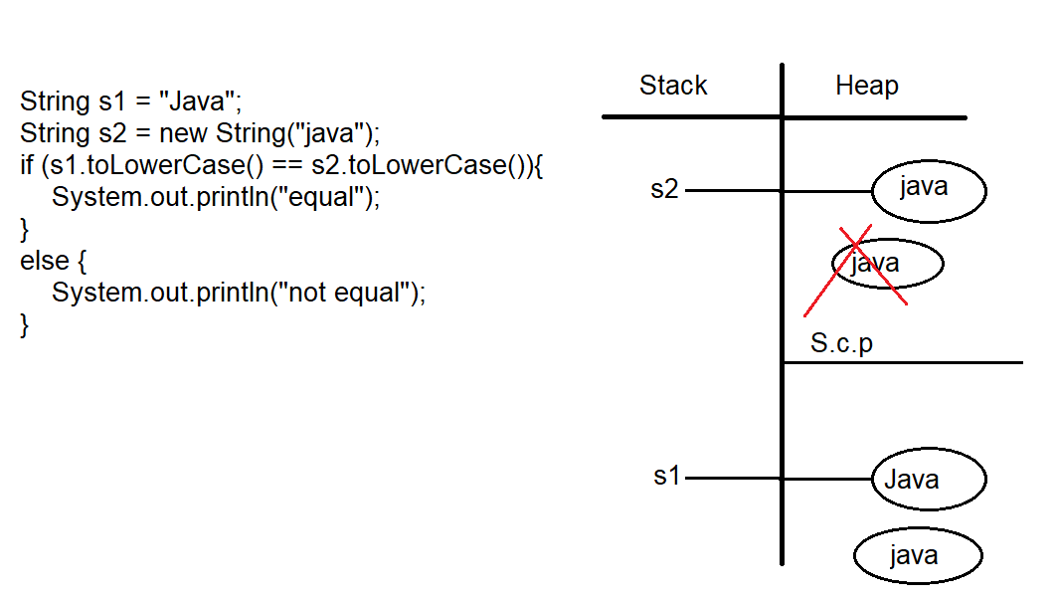

// while executing if condition since runtime operation and data is being changed a new object will be created in the heap. And even though runtime operation is made on s2, and there is no change in its data s2, no new object is created,

The 2 objects in the heap have different address, else block is excueted

When else block is executed, as the object is not collected by reference variable garbage collector cleans it.

Eg: String_Eg56

// go through the program

Eg: String_Eg57

// go through the program

Eg: String_Eg58

// go through the code

Eg: String_Eg59

// since s1 and s2 are of String type we are assigning s2 data to s1 so no compilation error.

Eg:String_Eg60

// String is immutable, we cannot add data on same object, if we to try to perform any operation on String (using method) a new object is created for that change, and if that object is not collected by reference variable it is cleared by garbage collector.

Eg: String_Eg61

// StringBuilder is mutable, we can add data on same object.

Eg: String_Eg62

// go through the code

Eg: String_Eg63

// whenever you try to print a reference, internally toString() method is called.

Note: if a class is final then that class cannot be inherited or extended, String class is final.

Eg:String_Eg64

“” (no space is considered) and “ “ are different

// go through the program

Eg: String_Eg65

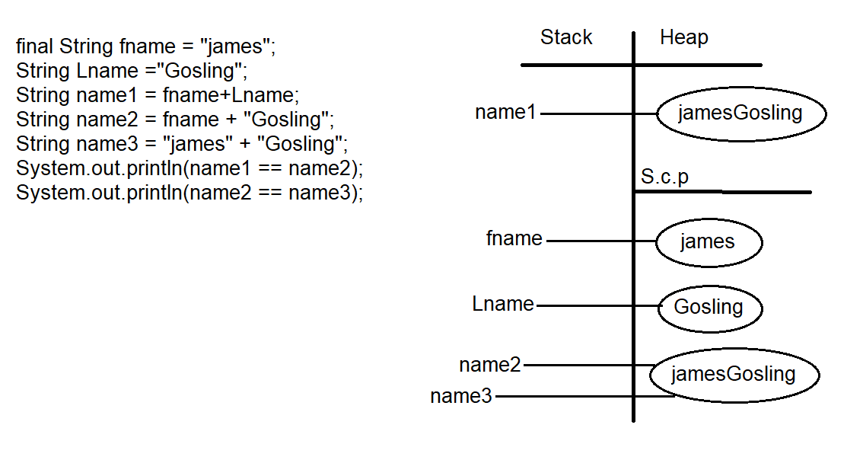

final variables are evaluated at compile time

Eg: Palindrome_Using_String_Methods

// String is internally stored as char array, to access that we use charAt() method

Eg: Converting _String_To_Char_Array

// go through the program

Eg: Anagram

With same no of used characters in the word another word should be formed.

// go through the program

Eg: panagram

The string should contain all the 26 alphabets irrespective of their repeatation.

Eg: String_Eg66

in the expression the first one is String the remaining expression is also treated as String even though if there are other type literals.

Eg: String_Eg67

In the expression if the first one is other than String literal, the expression is evaluated normally and then concatenated with string.

Eg: String_Eg68

In String objects only + operator is allowed other operators will result in the CompileTimeError

Eg: String_Eg69

// go through the code

Eg: String_Eg70

Here the break statement in switch break only switch but not for_loop (the break only stops one loop . here that is switch . ) labelled break is used to break for_loop.

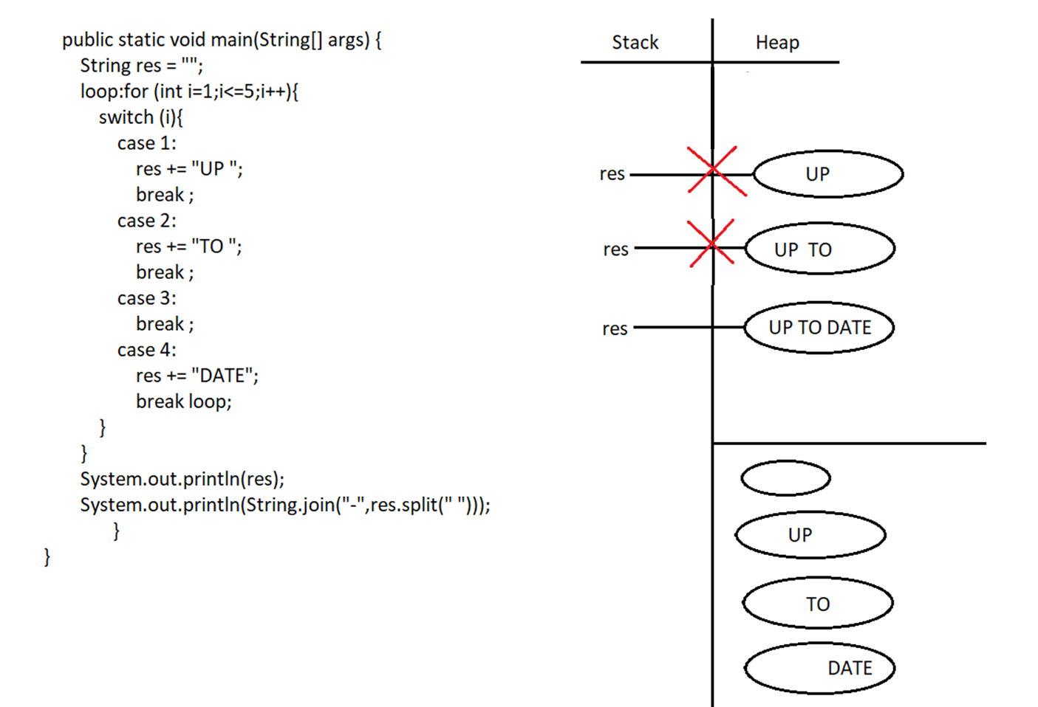

String is immutable. but the changes you are collecting in the same variable. so every time a new object of res is created.

String.join(“-“,[“UP“,TO”,DATE])

Split method gives array of string

Join method will take array at each index and join with “-“ .

Eg: String_Eg71

// go through the code

Eg: String_Eg72

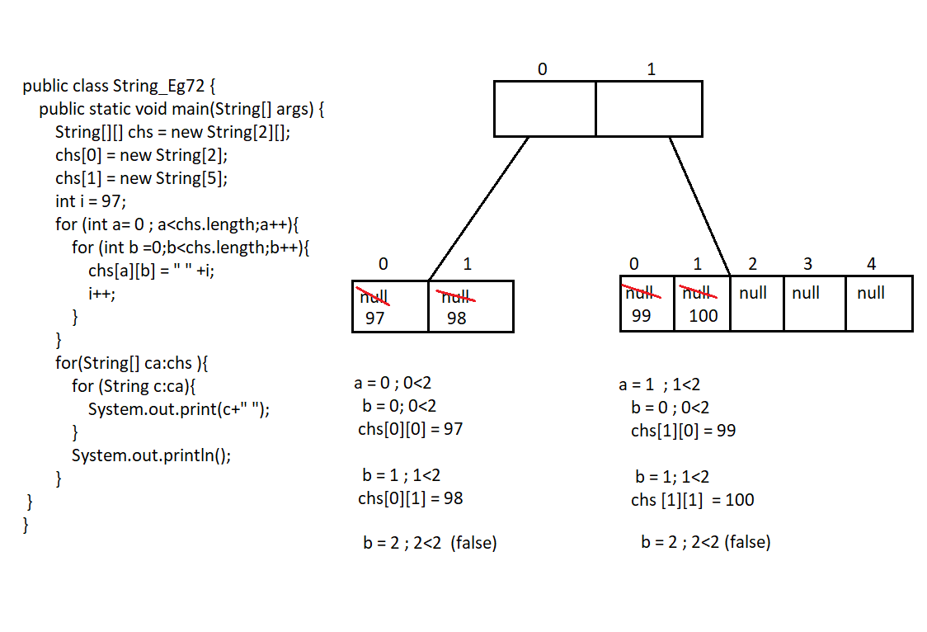

// for each loop is used for printing the elements.

Eg: String_Eg73

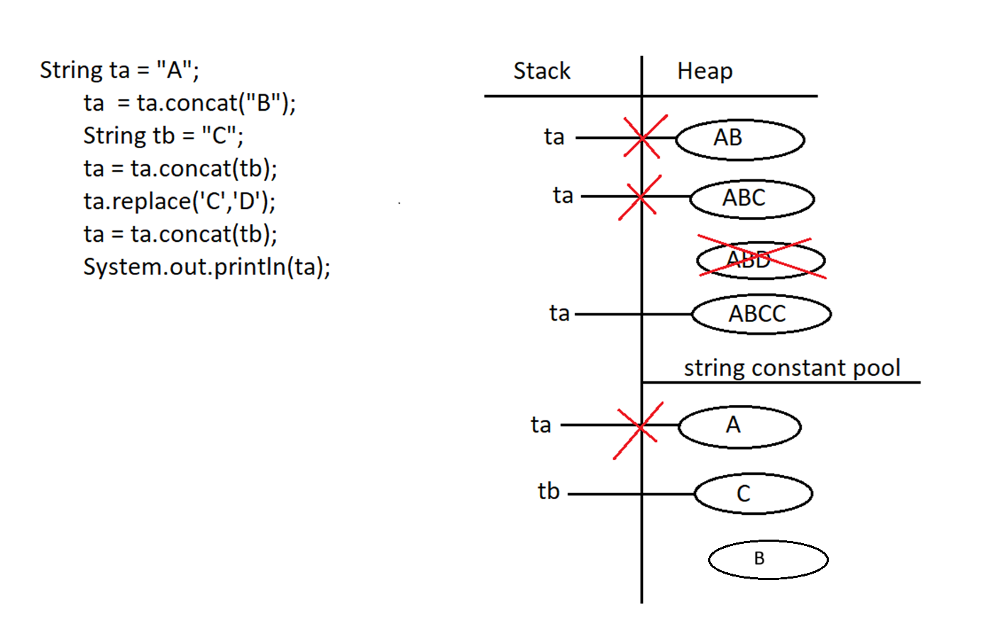

Eg: String_Eg74

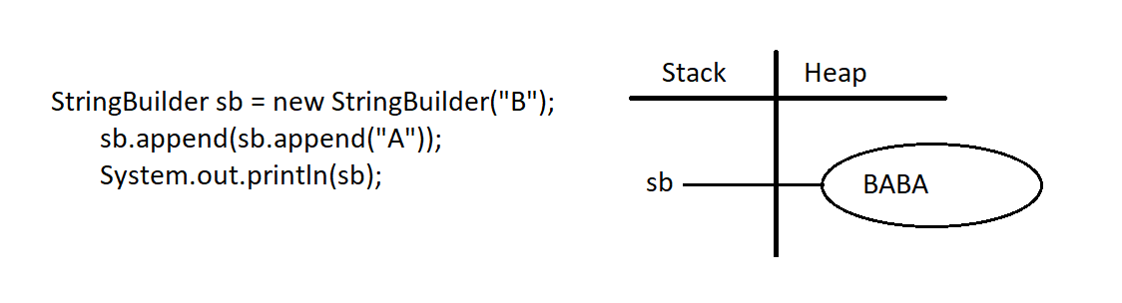

In string builder change will be reflected in same object.

//try with single quotes.

Eg: String_Eg75

// go through the code

The index(int ch ,int fromindex )

Here index is counted from 0.